Episcopal Diocese of Rhode Island Creation Care Ministry Resilience Guide

Climate Change Resources
A Faith Leader’s Guide to the 4th National Climate Assessment- Washington Interfaith Staff Community Energy and Environment Working Group

Catholic Apostolate Center Resources: Laudato Si’ on the Care of Our Common Home

Committee on Spirituality, Multifaith Outreach & Science (COSMOS) is a subcommunity of American Meteorological Society (AMS) and non-AMS members committed to incorporating perspectives based on faith, religion, or spirituality.

Creation Justice Ministries’ Faithful Resilience Guide A 6-part guide to building spiritual, physical, and social climate resilience in your faith community.

EPA's Saving the Rain Green Stormwater Solutions for Congregations This guide was created to help congregations work through the process of enhancing their grounds by implementing green stormwater management practices.

Episcopal Relief & Development US Disaster Program Preparedness Planning Guide For Individuals, Congregations, and Parishes: Make a plan, be informed and get a kit.

Fifth National Climate Assessment - Social Systems and Justice chapter which provides insights into how people understand, experience, and respond in different ways to climate change as well as the Northeast chapter.

National Council of Churches USA, Eco-Justice Program Office’s white paper entitled “Climate and Church: How Global Climate Change Will Impact Core Church Ministries.”

Week of Compassion- Congregational Guide for Disaster Preparedness: aims to help congregations think about disaster preparedness and response, in order to
position themselves to serve their people and their greater communities.

Existing Infrastructure Adaptation
Urban Land Institute’s Resilient Retrofits: Climate Upgrades for Existing Buildings introduces readers to the opportunities and challenges of preparing existing buildings for accelerating physical climate risks, including extreme temperatures, floods, storms and high winds, seismic risks, water stress/drought, and wildfires. The report includes a summary of several design strategies for each physical climate risk, a selection of public-sector policies influencing the retrofit context, and an array of financing solutions applicable to retrofits.

Resilience Hubs
- Green the Church & California Interfaith Power & Light prepared Creating Sanctuary: Turning Houses of Worship into Climate Resilience Hubs.

- Using tools such as radios are a great way to prepare and stay connected. Here is an example of the application and the recommended GMRS radios to buy. Rhode Island’s GMRS users and radio hobbyists (‘hams’) want to answer your questions, help you, and connect you with others in your community. Sign up here.

- STORMTOOLS brings our coastal flooding predictions to the landscape, making it easier to visualize impacts to roads, properties, and structures. This online map helps homeowners and municipalities in Rhode Island better understand their risks from coastal storms and flooding, and to plan for sea level rise by visualizing the magnitude and impacts of coastal flooding.

- MyCoast collects and analyzes pictures and data relating to coastal events. Information collected through this site is used to visualize the impact of coastal hazards and to enhance awareness among decision-makers and stakeholders and provide information for researchers.

Mental Health / Daily Habits
· Diet – eat slightly less dairy and beef which can generate greater pleasure.
· Swap out more sustainable products.
· Carpool with people you enjoy being with.
· Avoid fast fashion – buy a few, high quality clothes that will last longer or thrift.
· Don’t overcommit to travel because you can feel burned out.

Podcasts

Blue Theology Podcasts
- The Happiness Lab Podcast: Dr. Laurie Santos (Yale’s ”Happiness Professor”) outlines ways in which we can care more about threats to the planet and maybe react to them in more positive, happiness-inducing ways. Podcasts focused on climate change include:
    - “Why our Brains Don't Fear Climate Change Enough” with Harvard psychologist Dan Gilbert
    - “Being Green Doesn't Mean Sacrificing Fun... or Cutting Out Meat” Jiaying Zhao and Liz Dunn have pioneered the idea of "Happy Climate"
    - “Being Green Doesn't Mean Sacrificing Fun... or Cutting Out Meat” with scientist Adam Aron said making small contributions to the climate movement can make us feel more connected, more fulfilled and happier.
- Dr. Lisa Miller: How Does Spirituality Protect Our Mental Health? Dr Lisa Miller and the Surgeon General delved into the science that explains spirituality’s protective effects on mental health. They also discuss the universal human need for an inner life that connects us to something greater than ourselves, which lends itself to getting more involved in the climate movement.

Articles
- Blue Theology Tidings
- Deep Sea Divinity
- Exploring Blue Theology: An Interview with Rev. Deborah Streeter
- The Christian Call to Care for the Ocean

Books
Disaster Ministry Handbook By Jamie D. Aten, David M. Boan
Spiritual Care for Young People in a Climate Crisis by Talitha Amadea Aho
Church of the Wild by Victoria Loorz
Undrowned: Black Feminist Lessons from Marine Mammals by Alexis Pauline Gumbs
An Altar in the World by Barbara Brown Taylor
The Death and Life of Monterey Bay by Stephen R. Palumbi
​Low Carbon Diet: A 30 Day Program to Lose 5000 Pounds--Be Part of the Global Warming Solution! by David Gershon

Renewable Energy Resources
Energy Savings Programs
Interfaith Power & Light solar resources page provides information on financing, solar installers, and a map of other congregations in your community with solar.
Partners

External organizations

Adamah: Vibrant Jewish Life In Deep Connection with the Earth. We believe in the ancient Jewish teaching that people and planet are one, adam and adamah. (There is a Rhode Island chapter focused on the Jewish Youth Climate Movement.)

Blessed Tomorrow: A coalition of diverse religious partners working to advance climate solutions in faithful service to God.

CREW: Communities Responding to Extreme Weather: A network of local leaders building grassroots climate resilience through inclusive and hands-on education, service and planning.

Creation Justice Ministries: A network of Christian communities that advocates for environmental policy and theological education.

Dayenu: A Jewish Call to Climate Action: A movement of American Jews confronting the climate crisis with spiritual audacity and bold political action.

EcoAmerica builds institutional leadership, public support and political resolve for climate action and advocacy in the United States, particularly among faith communities. EcoAmerica features EcoAmerica's Blessed Tomorrow program.

GreenFaith: Green faith United States brings together people of all faiths and spiritualities to work for climate justice.

Green The Church: an organization that promotes solar energy and clean energy for Black congregations and communities.

Humanitarian Disaster Institute: Sponsored by Wheaton College (IL), HDI is a global hub for Christian education and thought-leadership navigating humanity’s most complex and catastrophic challenges.

Interfaith Partners for the Chesapeake equips people of faith to honor, protect, and restore our shared watershed.

Interfaith Power and Light: A national network of faith communities that advocate for environmental stewardship and climate justice.

Interreligious Eco-Justice Network. A Connecticut-based interfaith environmental organization that works to inspire and empower religious communities and their spiritual allies to protect our planet through education, engagement and advocacy.

Jewish Earth Alliance: A grassroots network of communities working together to enable Jews to engage in the policy process at the Federal level as citizens.

Land Justice Futures: (Formerly the Nuns and Nones Land Justice Project) Together with religious communities and movement partners, the organization creates new land transitions rooted in racial and ecological healing.

United Church of Christ
- Southern New England Conference is taking action for climate and environmental justice by focusing on connecting, organizing, divesting, and advocating. Rev. Jim Antal, a national spokesperson for climate change for the United Church of Christ. He has written “Climate Church, Climate World”, how people of faith must work for change.
- Environmental Justice Ministries: From the birth of the environmental justice movement in the 1980s to the local ministries of churches throughout the country today, the United Church of Christ has been making a profound difference in caring for God’s creation. Learn more about our history, the Creation Justice Church program, Earth Day resources, the Pollinator newsletter, Creation Justice Webinars, and the work of the UCC Council for Climate Justice.

Episcopal and Anglican Organizations

- Episcopal Camps and Conference Centers: Dedicated to formation and transformation of people of all ages, partly by nurturing our relationships with God, each other, and creation.

- Episcopal Relief & Development: Facilitates healthier, more fulfilling lives in communities struggling with hunger, poverty, disaster and disease, with a particular emphasis on climate.

- Anglican Communion Environmental Network: Guided by the Fifth Mark of Mission, members of the Anglicans and Episcopalians strive to safeguard the integrity of creation and sustain and renew the earth.

- Other Leaders

- Diocese of Maine: Creation Care: Social Justice Ministry Creation Care Council’s mission is to bear witness through the people of the Diocese of Maine to the need for justice in our relations with all living things, with those on the margins who bear the brunt of climate change, and with all creation. We aim to advocate, network and inspire through education, action, and worship so that the Diocese as a whole might fulfill its calling to care for creation.

- Diocese of Massachusetts, Creation Care Justice Network

- Diocese of New Hampshire: Earth Care Network’s purpose is to lead the Episcopal Church of NH to care for the earth and to honor God in the face of all creation.

- Diocese of Olympia, Bishop’s Committee for the Environment

- Diocese of Virginia, Creation Care Committee & Habitat Restoration Group

- Diocese of Washington, Environmental Network

- Diocese of Western Massachusetts, Creation Care: Season of Creation 2024: A Celebration Guide for Episcopal Parishes.

- Episcopal Church in Connecticut (ECCT): The focus of the Creation Care Ministry Network is to share creation care resources and support emerging and established creation care programs, events, initiatives and partnerships in ECCT.

- Sustain Island Home: The Diocese of California’s web-based learning and climate advocacy platform, which Organizes the Carbon Tracker for the entire Episcopal Church.

Green Team Resources

Creation Care Corner: Green Bin Envy
You’ve seen them around town – those cute little green bins on the side of the road with the cheerful “Compost” logo. You’ve probably heard from friends, neighbors, and fellow parishioners how easy and convenient it is to have their compost picked up every other week. Maybe they brag about how little trash they create now that they’re composting all their food scraps; how they can even put bones, shells, bread, dairy products, and paper towels in their compost bin; how the bins snap shut to keep odors in and critters out, and how, every spring, they get a voucher for a free bag of compost to use on their lawn or garden. They might even get a little self-righteous, talking about how they’re keeping waste out of the landfill and returning beneficial nutrients to the soil. Maybe you’ve been thinking about signing up for compost pick-up, too, but are not sure where to begin. Great idea! And Creation Care Season is the perfect time to take that step and do something truly beneficial for “this fragile earth, our island home.” Simply click on this LINK to the Black Earth Compost website and sign up for the residential compost program – and be sure to click on the box for email reminders the day before each compost pick-up.

Creation Care Corner: Resolve to recycle right!

What’s the best thing to do with plastic bags?
Rhode Island became the first state in the nation to have a comprehensive plastic bag recycling program in place! Plastic bags can be recycled, but no, they should NEVER go in your recycling bin. Plastic bags clog and damage the machinery used for recycling other items, so they must be handled separately. With very few exceptions (clingy food wrap, biodegradable bags, and fertilizer/pesticide bags), if a plastic bag or film can be stretched, even just a little, you can return it to a large store in RI for recycling. To test this out, press the film over your thumb. One of the tougher-to-stretch but acceptable films is the kind used to line many cereal boxes. Did you know bread, cereal, bagels bags, drying cleanings bags, newspaper sleeves, zippered sandwich bags, birdseed, ice, and plastic mailing envelopes (labels removed) can be recycled in the receptacles found in entrance of Shaw's and Stop & Shop. Drop off Centers for Plastic bags in RI can be found on the RI Resource Recovery CO. (rirrc.org). Look for the symbol that says “Store Drop-off” (see below). So give the thumb test a try and put plastic bags where they belong – in a designated drop-off bin.
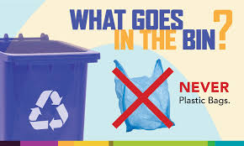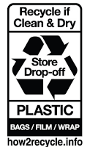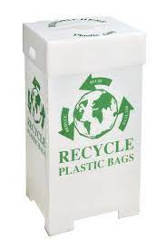

Creation Care Corner: Wash, Rinse, Repeat
Those heavy jugs of laundry detergent are not just a burden to carry home from the store – they’re also a burden on the environment. Even though the jugs are recyclable, the sad truth is that most of them end up in landfills or add to mountains of plastic waste. And because liquid detergent is up to 90% water, the jugs are bulky and heavy, requiring more resources to transport and store. Detergent pods are a bit better, but they, too, usually come in plastic containers. For a simple way to make laundry easier on yourself and on the environment, consider switching to laundry detergent sheets. These flexible detergent sheets dissolve completely in water, can be cut to fit various size loads, and are great for travel. Best of all, they come packaged in a thin paper envelope, which fits easily in a cupboard or drawer and can be recycled when empty. Detergent sheets may be hard to find at the supermarket, but they’re widely available through online retailers.

Making the Most of Your Green Bin
Now that you’ve signed up for residential compost pick-up with Black Earth Compost (if you didn’t get to it yet, here’s the LINK), you’re undoubtedly enjoying the benefits of creating less trash each week – maybe you even skip a week of trash collection and save on trash bags, too! You’ve mastered the basics, such as putting a folded paper bag in the bottom of your compost bag to absorb moisture, and wrapping up stinky things like meat scraps and fish skins in newspaper before putting in your bin. And you’ve probably learned that compostable bags don’t last forever (obviously!), so only buy a few months’ supply and keep them away from heat and light. Now it’s time to take your composting game to the next level and consider using compostable products instead of disposable cups, plates, bowls, cutlery, and – for all you bakers out there – even parchment paper. But beware! There are some compost wannabes that might claim to be compostable, but do not meet the strict standards for making organic compost. Luckily, there’s an easy way to find the right products. Just look for one or more of these symbols when you shop online or at the store:
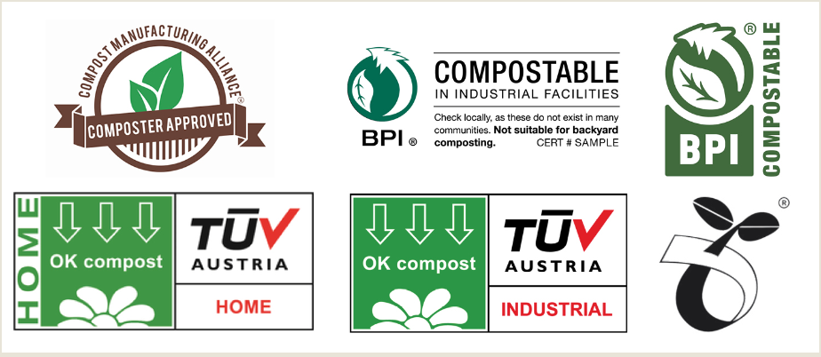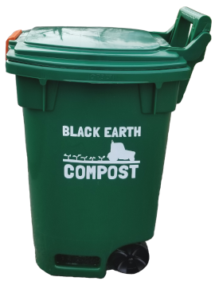
For more information, log in to your Black Earth Compost account and click on the “Shop” tab. And if you haven’t checked your Black Earth account in a while, log in now and take a look at your dashboard to see how much waste you’ve diverted from the landfill. Thanks for doing your part to make Creation Care season last all year long!

Refill Station- A Zero Waste Shop. Here are links to resources for Personal Care and Household Cleaning Refilling stations in the US and RI.

Environmental Working Group identifies environmentally friendly household products and personal care products such as:
Dishwasher Pods: Clean People All Natural Dishwasher Pods

Reusable Paper Towels: ThanKiu2 Reusable Paper Towels

Mesh Produce bags: Ecowaare Set of 15 Reusable Mesh Produce Bags

Reusable Bowl covers: TCOTBE 60 Reusable Elastic Food Bowl Storage Covers

Reusable Food/Snack Storage bags: Reusable Storage Bags Stand Up

Concentrated Foaming Hand Soap with Bottle and Refills: Google Tirtyl Hand Soap

Laundry: Wool Dryer Balls -Erosbon and Earth Breeze Laundry Detergent Sheets

Switch out household products to more environmentally friendly ones!
VS. 
Old choice ➡️ New, Planet Friendly Choice
Dishwasher detergent ➡️ Dishwashing pods (without fragrances and dyes)
Paper towels ➡️ Reusable cloth towels
Plastic produce bags ➡️ Reusable mesh bags.
Plastic wrap ➡️ Beeswax wraps and/or reusable plastic covers
Ziploc bags ➡️ Reusable food storage bags
Dryer fabric sheets ➡️ Wool dryer balls
Clothes washing detergent ➡️ Detergent sheets
Chemical cleaning products ➡️ Safer cleaners (Meyer's, Seventh Generation, Honest)
Scented paraffin candles ➡️Beeswax candles (burn cleaner)
Liquid hand soap ➡️ Concentrated, foaming refills
Shampoo bottles ➡️ Shampoo bars or sulfate free shampoo
Paper napkins ➡️ Cloth napkins

